SIMATS ENGINEERING (SAVEETHA SCHOOL OF ENGINEERING)
Department of Computer Science and Engineering
CO2 ASSESSMENT TOOL 1 — Scenario-Based Requirement Analysis
Course Code: | CSA1007 | Course Title: | Software Engineering
CO Assessed: | CO2 | Assessment: | Assessment Tool 1 – Scenario-Based Requirement Analysis
Weightage: | 20% | Total Marks: | 25
CO2 Statement: | Perform detailed requirements analysis, design scalable architectures, and prioritize features with a focus on cross-disciplinary skills.
Student Name: | D. Vyshali | Reg. No.: | 192411197
Date: | 28/08/2026 | Duration: | 60 minutes

Code of Conduct
I, D. Vyshali (192411197), certify that this submission is my original work and that I have adhered to the guidelines specified for this assessment. I understand that any violation of academic integrity rules will result in disciplinary action.
Signature of the Student: D. Vyshali

Problem Statement 17: AI-Based Fashion Supply Chain Optimization Platform

1. Scenario Study and Analysis

1.1 Business Domain
The assigned problem statement falls within the fashion retail and supply chain management domain. Fashion retail is characterized by short product lifecycles, strong seasonality, fast-changing style trends, and multi-tier supply networks spanning designers, manufacturers, suppliers, warehouses, and stores. Because trends shift quickly, fashion retailers routinely face two costly extremes at the same time — stock-outs of trending items that erode revenue, and excess inventory of slow-moving styles that must be liquidated at heavy discounts.
Manual, spreadsheet-driven planning and fragmented supplier communication make it difficult for brands to react to shifting trends, verify supplier reliability, or maintain visibility over shipments. This creates a clear need for an AI-driven, data-centric platform that can forecast demand, optimize inventory distribution, coordinate suppliers, track shipments, and provide consolidated performance visibility to decision-makers.

1.2 Problem Description
Design and develop an AI-Based Fashion Supply Chain Optimization Platform that uses historical sales, seasonality, and trend data to forecast product demand; optimizes inventory allocation across warehouses and retail stores; coordinates supplier replenishment cycles; tracks shipments in real time; monitors sales trends to detect fast- and slow-moving products; and generates consolidated supply chain performance reports for business stakeholders.

1.3 Existing Challenges
- Inaccurate, manual demand forecasting leads to stock-outs of trending styles and overstock of slow movers.
- Inventory is allocated without a data-driven, demand-aware method, causing regional imbalances.
- Manual supplier coordination delays purchase orders and replenishment cycles.
- Shipment status is not visible in real time, making delays hard to anticipate.
- Sales trends are identified too late to act on, missing promotion/reorder windows.
- Supply chain performance data is fragmented, making executive reporting slow and error-prone.

1.4 System Objectives
- Forecast product demand using historical sales, seasonality, and trend data.
- Optimize inventory allocation across warehouses and retail stores.
- Coordinate suppliers for timely, reliable replenishment.
- Track shipments in real time across the logistics network.
- Monitor sales trends to detect fast- and slow-moving products.
- Generate consolidated supply chain performance reports.

1.5 Key Stakeholders
The platform serves a cross-functional group of stakeholders, each with distinct goals that the requirements below must address:
Stakeholder | Role in the Project | Primary Interest
Business / Brand Executives | Set strategic direction; review supply-chain KPIs | Profitability and brand growth
Supply Chain Managers | Own inventory allocation and overall coordination | Balanced stock levels, fewer disruptions
Procurement & Sourcing Officers | Manage supplier relationships and purchase orders | Reliable, cost-effective sourcing
Warehouse & Logistics Staff | Receive, store, dispatch inventory; track shipments | Accurate, real-time shipment visibility
Suppliers / Vendors | Fulfil purchase orders; share production status | Clear demand signals, realistic lead times
Merchandising & Sales Team | Interpret sales trends; plan assortments/promotions | Early trend detection
Data Science / AI Team | Build and maintain forecasting/optimization models | Access to clean, timely data
System Administrators | Maintain infrastructure, security, and integrations | Reliability and controlled access

2. Functional and Non-Functional Requirements

2.1 Functional Requirements
Functional requirements are grouped by the six functional modules that mirror the platform's end-to-end process flow, plus a supporting User & Access Management module.
ID | Module | Requirement
FR-1 | Demand Forecasting | Generate demand forecasts per product/SKU using historical sales, seasonality, and trend data.
FR-2 | Demand Forecasting | Provide forecasts broken down by region and season, with a confidence interval.
FR-3 | Inventory Allocation | Recommend store-wise/warehouse-wise allocation based on forecast vs. current stock.
FR-4 | Inventory Allocation | Detect and alert managers to understocked or overstocked items.
FR-5 | Inventory Allocation | Allow authorized managers to manually override allocation recommendations.
FR-6 | Supplier Coordination | Display supplier performance metrics (on-time delivery, rejection rate, lead time).
FR-7 | Supplier Coordination | Generate and transmit automated purchase orders when replenishment conditions are met.
FR-8 | Supplier Coordination | Allow suppliers to acknowledge orders and update production/shipment status.
FR-9 | Shipment Tracking | Track shipment location and status in real time via carrier integration.
FR-10 | Shipment Tracking | Notify warehouse staff of dispatch, transit, delay, or delivery events.
FR-11 | Sales Trend Monitoring | Continuously analyze POS data to detect fast- and slow-moving products.
FR-12 | Sales Trend Monitoring | Flag emerging fashion trends and alert merchandising/marketing teams.
FR-13 | Reporting | Generate consolidated supply chain performance reports (KPIs, stock, delays).
FR-14 | Reporting | Provide a summary dashboard for business executives.
FR-15 | Reporting | Support scheduled and on-demand report export as PDF/spreadsheet.
FR-16 | User & Access | Authenticate users and enforce role-based access control.
FR-17 | User & Access | Maintain an audit trail of key actions (order approvals, overrides).

2.2 Non-Functional Requirements
Quality Attribute | Requirement
Performance | Forecasts generated within 5 seconds per SKU query; dashboards load within 3 seconds.
Scalability | Scales horizontally to additional regions, stores, and SKUs without redesign.
Security | Data encrypted in transit/at rest; role-based access with MFA for admin roles.
Reliability / Availability | 99.5% uptime; shipment status reflects within 15 minutes of a carrier update.
Usability | Dashboards usable by non-technical staff with minimal training.
Maintainability | Forecasting/allocation models retrainable without a full redeployment.
Interoperability | Integrates with ERP/POS and supplier/logistics APIs via REST/EDI.
Data Privacy & Compliance | Sales/customer data handled per applicable data protection regulations.
Auditability | All critical transactions logged with timestamp and user identity.

3. Actors and Use Cases
Actor | Type | Key Use Cases
Merchandising Manager | Primary | Forecast Product Demand; View Regional/Seasonal Forecast; Monitor Sales Trends
Supply Chain Manager | Primary | Forecast Product Demand; Allocate Inventory; Manage Stock Alerts
Procurement Officer | Primary | Evaluate Supplier Performance; Send Purchase Order
Warehouse / Logistics Manager | Primary | Manage Stock Alerts; Track Shipment; Receive Shipment Notification
Business Executive | Primary | View Regional/Seasonal Forecast (summary); Generate Supply Chain Report
System Administrator | Secondary | Manage User Access
Supplier (External) | Secondary | Send Purchase Order (acknowledge); Receive Shipment Notification (status)
Authentication Service | Supporting | Authenticate User — included by use cases requiring login

Use Case Diagram
The diagram below shows primary and secondary actors interacting with the platform, including «include» and «extend» relationships among use cases.
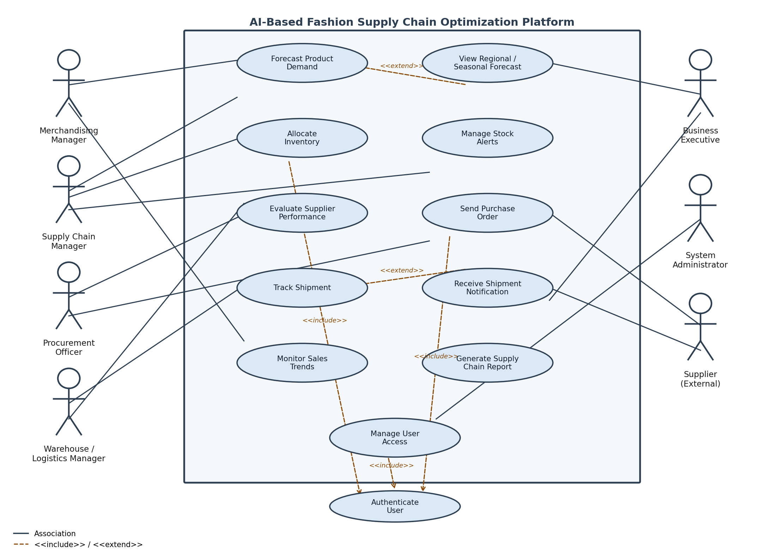
Figure 1: Use Case Diagram — AI-Based Fashion Supply Chain Optimization Platform

4. Software Requirement Specification (SRS)

4.1 Introduction and Scope
This SRS covers the AI-Based Fashion Supply Chain Optimization Platform for a fashion retail organization seeking to modernize demand planning, inventory allocation, supplier coordination, shipment tracking, and performance reporting through an AI-driven, distributed platform.
In scope: demand forecasting, inventory allocation with manual override, supplier performance and purchase orders, shipment tracking, sales trend monitoring, reporting/dashboards, and role-based access control.
Out of scope: in-store POS transaction processing, supplier factory production scheduling, and direct financial settlement with suppliers (handled by existing systems).

4.2 Key Use Case Descriptions
UC-1 Forecast Product Demand — Actor: Merchandising/Supply Chain Manager. Precondition: at least 12 months of historical sales data available. Main flow: the actor selects a product/SKU and time horizon; the AI/ML engine retrieves historical sales, seasonality, and trend data and generates a demand forecast with a confidence interval, optionally broken down by region and season. Postcondition: the forecast is available to downstream modules. Exception: SKUs with insufficient history receive a flagged, category-level proxy forecast.
UC-2 Allocate Inventory — Actor: Supply Chain/Warehouse Manager. Precondition: a demand forecast and current stock levels are available. Main flow: the allocation engine compares forecast against stock by location and proposes a store-wise/warehouse-wise allocation plan; the manager reviews, approves, or manually overrides it. Postcondition: the approved allocation is recorded and warehouses are notified. Exception: overrides are logged with a reason code for audit.
UC-3 Send Purchase Order — Actor: Procurement Officer (primary), Supplier (secondary). Precondition: an approved replenishment requirement exists. Main flow: the officer reviews and confirms the order; the system transmits it to the supplier via API/EDI or portal; the supplier acknowledges and provides an expected fulfilment date. Postcondition: the order is logged as sent with acknowledgement recorded. Exception: if the supplier does not acknowledge within the SLA window, the order is escalated to the procurement manager.
UC-4 Track Shipment — Actor: Warehouse/Logistics Manager (primary), Carrier (secondary). Precondition: a shipment has been dispatched with a valid tracking reference. Main flow: the system receives carrier status updates and updates shipment status (dispatched, in-transit, delayed, delivered), notifying the warehouse manager of delays. Postcondition: shipment status is current and receiving staff are prepared. Exception: if the carrier feed is unavailable, the shipment is flagged 'status unknown' for manual follow-up.

4.3 Data Requirements
Data Entity | Key Attributes
Product / SKU | Style, size, colour, category, season, unit cost, price
Store / Warehouse | Location ID, region, capacity, current stock levels
Sales Transaction | SKU, store, quantity sold, date/time, channel
Demand Forecast | SKU, region, season, forecast quantity, confidence interval
Inventory Allocation | SKU, source warehouse, destination store, quantity, status
Supplier | Supplier ID, name, lead time, on-time rate, rejection rate
Purchase Order | Order ID, supplier ID, SKU(s), quantity, date, status
Shipment | Shipment ID, PO reference, carrier, tracking ref, status, ETA
User | User ID, role, store/warehouse assignment, permissions
Report / KPI Snapshot | Report ID, period, KPI values, generated-by, distribution

4.4 External Interface Requirements
User interfaces: web dashboard for executives, supply chain and procurement managers; mobile-friendly app for warehouse and logistics staff.
Hardware interfaces: optional integration with barcode/RFID scanners for stock movement capture.
Software interfaces: integration with existing ERP/POS systems, supplier EDI/API systems, and logistics carrier tracking APIs.
Communication interfaces: secure REST/HTTPS APIs and webhooks; email/SMS gateway for alerts and notifications.

4.5 System Features
- AI/ML demand forecasting engine generating SKU/region/season-level forecasts with confidence intervals.
- Inventory allocation optimization engine recommending and tracking stock distribution.
- Supplier coordination and purchase order module with performance metrics and automated ordering.
- Shipment tracking dashboard with real-time visibility and delay alerts.
- Sales trend analytics detecting fast-/slow-moving products and emerging trends.
- Reporting and executive dashboard with consolidated KPIs and scheduled/on-demand reports.
- Notification engine for email/SMS/in-app alerts across stock, order, and shipment events.
- Role-based access control with a full audit log across all modules.

4.6 Deployment Considerations
As a distributed platform serving stores, warehouses, suppliers, and executives across regions, the system should be deployed on a cloud-native, microservices-based architecture with independent scaling for the forecasting, allocation, and reporting modules. An API gateway should mediate access for external suppliers and carrier integrations, while a message queue decouples real-time shipment and POS event ingestion from downstream processing, supporting the reliability and scalability requirements defined in Section 2.2.

5. Assumptions and Constraints

5.1 Assumptions
- At least 12–24 months of reasonably clean historical sales data is available for forecasting.
- Suppliers are willing and technically able to integrate via API, EDI, or a supplier web portal.
- Warehouses and stores have reliable internet connectivity for real-time updates.
- End users have basic digital literacy and access to the required devices.
- Logistics/carrier partners can provide trackable shipment references and status feeds.

5.2 Constraints
Technical: must integrate with existing legacy ERP/POS systems, some with limited API support.
Operational: success depends on change management and staff training; forecast quality depends on consistent data entry across stores.
Economic: budget limits apply to cloud infrastructure, AI model training/retraining, and third-party API costs.
Legal/Regulatory: must comply with applicable data protection regulations and supplier contractual data-sharing terms.
Time: delivery must align with the seasonal planning calendar; missing a pre-season window delays value by a full season.

6. Requirement Validation — Completeness and Consistency

6.1 Completeness Check
Each stakeholder's primary interest (Section 1.5) is cross-checked against the functional requirements to confirm coverage: executives (profitability) → FR-13/14/15; supply chain managers (balanced stock) → FR-3/4/5; procurement officers (reliable sourcing) → FR-6/7/8; warehouse staff (shipment visibility) → FR-9/10; merchandising team (trend detection) → FR-1/2/11/12; IT administrators (reliability, controlled access) → FR-16/17 and the security/reliability NFRs. No stakeholder need was found unaddressed.

6.2 Consistency and Ambiguity Check
- The vague term 'real time' for shipment tracking was quantified as 'within 15 minutes of a carrier status change' to remove ambiguity.
- FR-4 (stock alerts) and the inventory allocation use case initially overlapped; FR-4 was scoped strictly to alerting while allocation logic remains in FR-3/UC-2, removing redundancy.
- 'Fast' forecast generation was quantified in the Performance NFR (5 seconds per SKU query) rather than left subjective.
- No contradictory requirements were identified between functional and non-functional requirements during review.

6.3 Suggested Improvements
- Add a requirement for forecast/model explainability so business users understand recommendations, improving trust and adoption.
- Add an explicit data retention and archival policy for historical sales and shipment data.
- Add an offline/degraded-mode capability for warehouses with intermittent connectivity.
- Add periodic bias/fairness monitoring for the AI forecasting model across regions and categories.

7. Conclusion
This Scenario-Based Requirement Analysis has examined the AI-Based Fashion Supply Chain Optimization Platform across its business context, stakeholders, functional and non-functional requirements, actors and use cases, and a full Software Requirement Specification, followed by a documented validation of completeness, consistency, and suggested improvements — providing a traceable requirements foundation for subsequent design and sprint planning.

